**How to install Jamf Protect on a device that’s not handled by a MDM-solution**

If not already there go to <https://download.su.se/dsa/Jamf%20Protect%20macOS/>

**Important - Jamf Protect General Requirements > Target computers with macOS 10.13 or later.**

1. The **Agent Installer** is same for all unmanaged clients. To download go to the catalog named “*Jamf Protect general agent install for all macOS clients*”.  
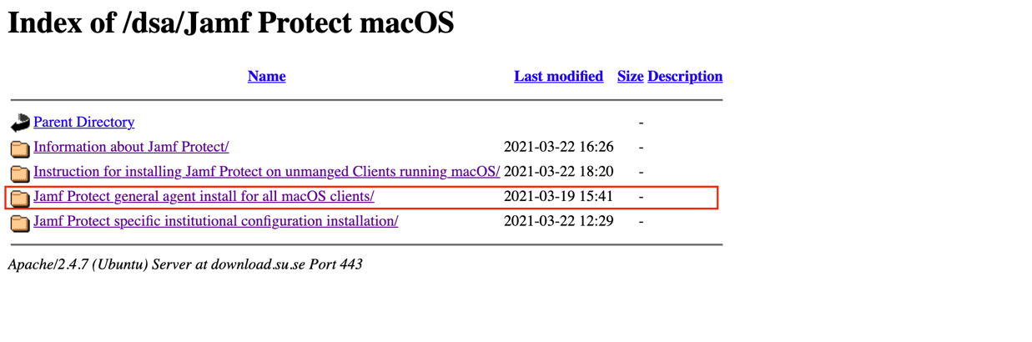

Download the **Jamf Protect** **Agent Installer** at this point named “*JamfProtect-1.3.2+268.pkg*”, that resides within “JamfProtect-1.3.2+268.dmg”

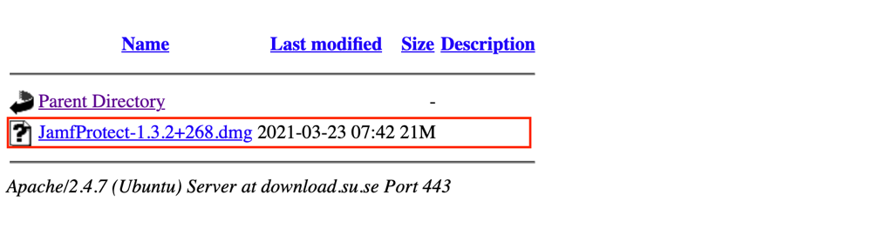

2. Then go to the catalog named “*Jamf Protect specific institutional configuration installation*” and find the number representing your department, click to open the catalog that represents your department, download the mobileconfig-file

If you are uncertain of the number that corresponds with your department you will find the information on this page:

<https://www.su.se/medarbetare/ekonomi/institutionslista>

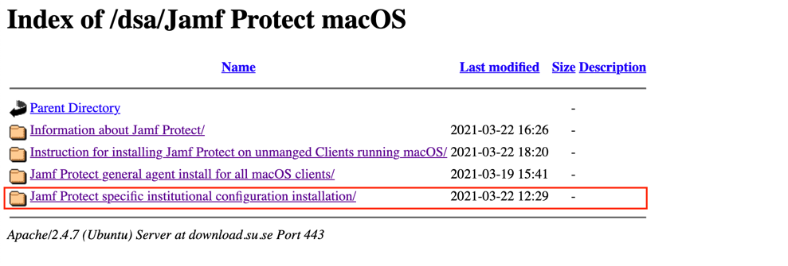

In the manual click to open the catalog representing “*example*” department 501.



In the manual, download the “*JamfProtect-Plan-501 department JP on unmanaged clients.mobileconfig*”.

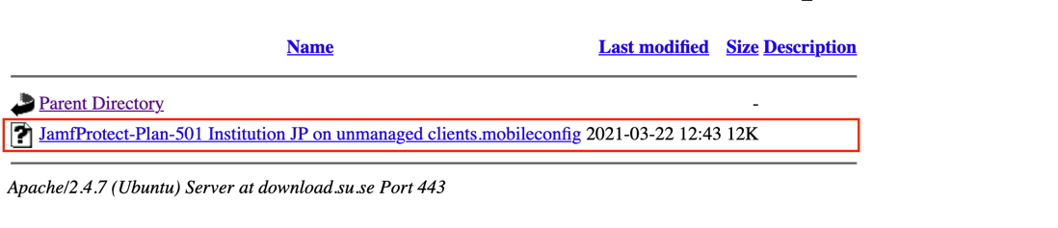

When you have downloaded the Jamf Protect Agent Installer and a mobileconfig representing your department click on the mobileconfig that you downloaded if you haven’t already been asked to do so.

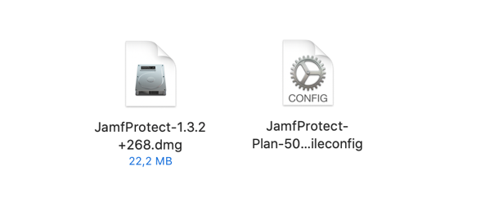

3. Next click the “*JamfProtect-1.3.2+268.pkg*” to install the Agent. After you have installed the agent follow these very important steps:

* Open System Preferences > Security & Privacy > Privacy > Full Disk Access and add the Jamf Protect agent. If you don’t see the Jamf Protect you need to navigate to

/Library/Application Support/JamfProtect/

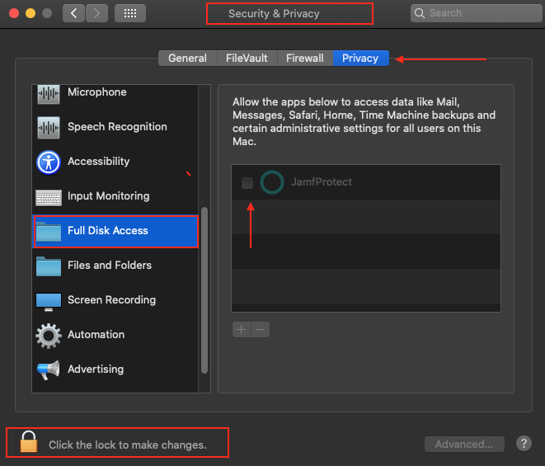

* In the same area of System Preferences do the same thing with Accessibility instead of Full Disk Access.
* Open Terminal.app and run this command to restart the agent with the new disk permissions:

sudo launchctl kickstart -k system/com.jamf.protect.daemon